Add the speech marks to the sentences.
This is great!
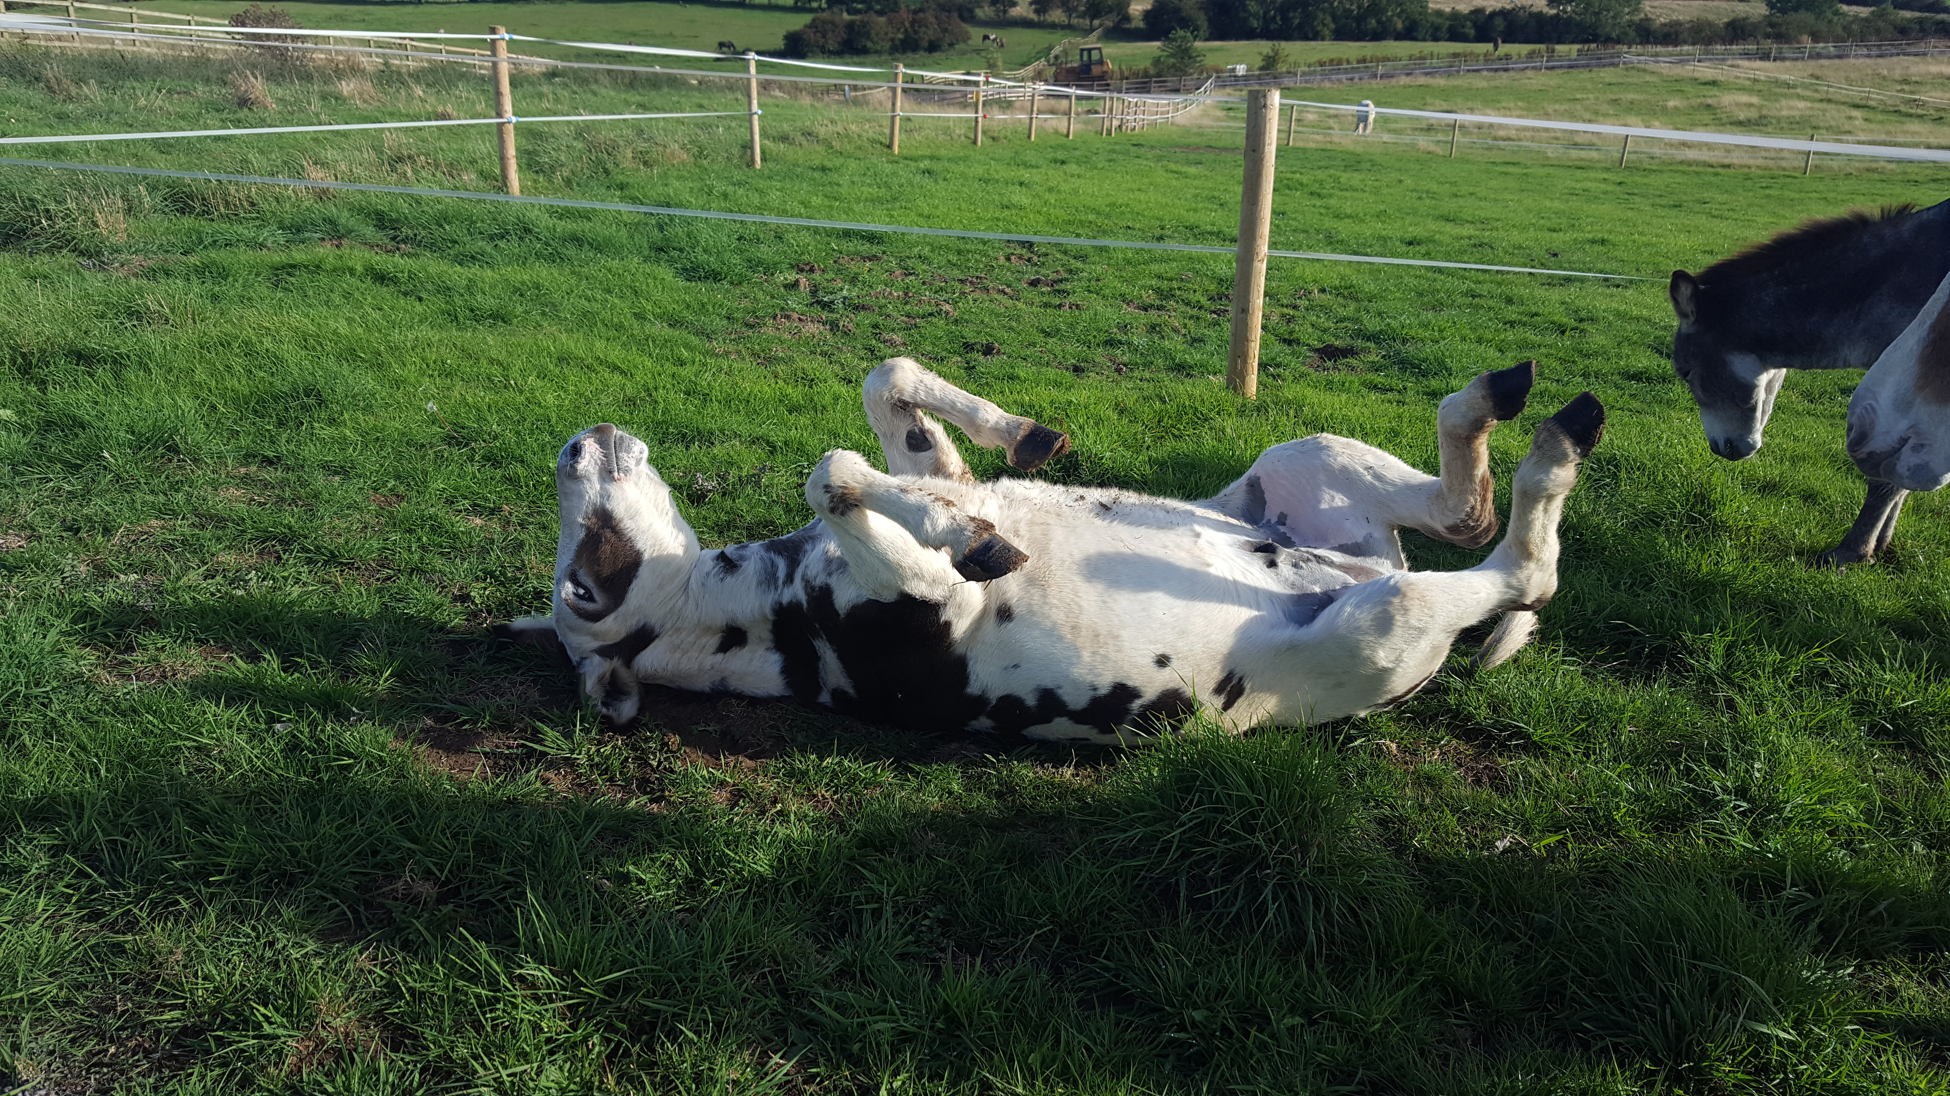
This is great! shouted the donkey.
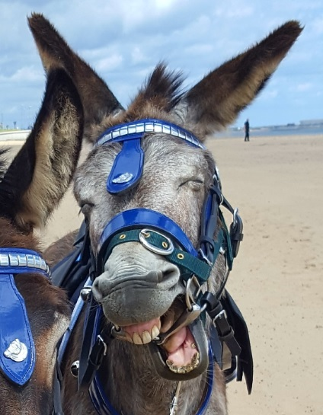
That was funny
Is it lunch time yet?
That was funny, giggled the donkey.
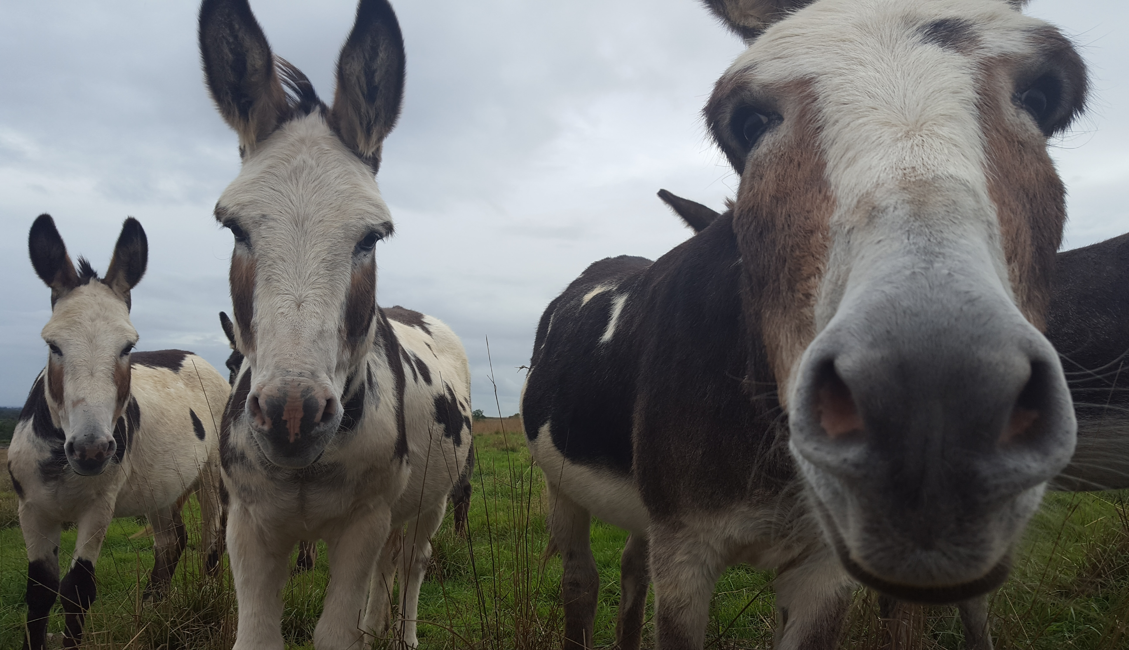
I have long ears
The donkey whispered, Is it lunch time yet?
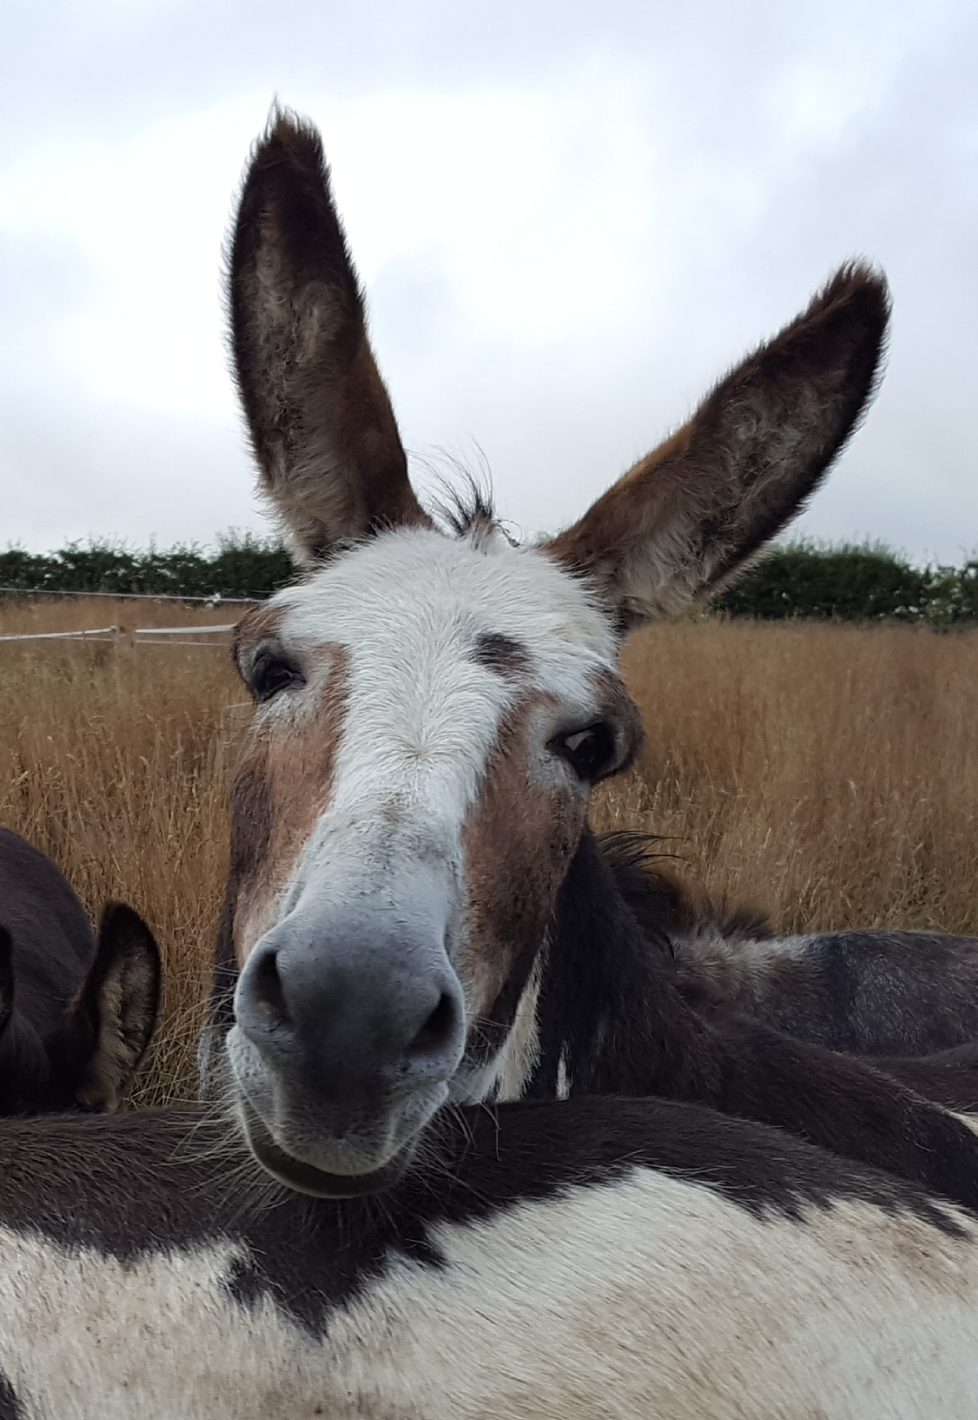
I have long ears, said the donkey.

